IST 363

Lab 09

This Lab Covers
- JavaScript – API Calls and JSON

Lab Corrections
No corrections this week. Woot!

JavaScript 3
Goal: The goal this week is to make a call to an API that will return a JSON database. You will use the data returned to populate the weather on the a website page. It will look like this with the dynamically populated data when you are done.
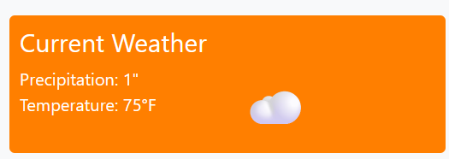
- Get the Weather from the API
The site we’ll be using to grab the weather is: https://open-meteo.com/en/docs. If you’ve used APIs before, fear not. You won’t need to log in or key or any of the other hoops you’ve had to jump through to get data.
Scroll the docs page to see what’s available. We want to get current weather for precipitation, temperature, and cloud cover for Syracuse, NY in US units (inches/Fahrenheit). You will see the API URL listed on the page. That is your endpoint. Paste the endpoint URL in your web browser to see what the data looks like. Be sure to click on the “raw” tab in Chrome.
- Simple Web Page with Weather Data
Start with an HTML page with only the required tags. Do the request to your endpoint and go through all the steps we worked through in the lecture to grab the current precipitation, temperature, and cloud cover.
Use your knowledge of the DOM, from last week, to populate this info into the body of the page.
- Cloud Cover Emojis
For the cloud cover, instead of reporting the amount, we will put up an emoji that is either ☁️or ☀️. Emojis are treated exactly like text so you can copy these out of the lab and use them in your code. You will have to check what the cloud cover number is and display the appropriate emoji.
- Putting It All Together on a News Site
Last but not least. Download my lab code from Blackboard. This is a news website page. Put all your JavaScript into an external JavaScript (.js) file. Write the link to include it on my news website page. Add the HTML code the code you worked on above into the news page. Your weather box should look exactly like the screenshot above minus your current weather data.
- Use the template to turn it in.
The End

